Alexander Baldree
06/24/26
Module 4.2 Assignment
CSD430

GitHub Link:
https://github.com/Panda-Alex21687/CSD430

Project Folder Structure:
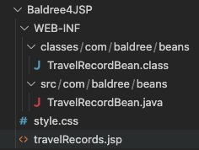

TravelRecordBean.java:
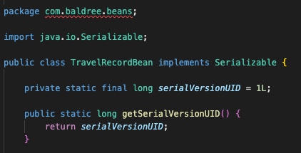

travelRecord.jsp:
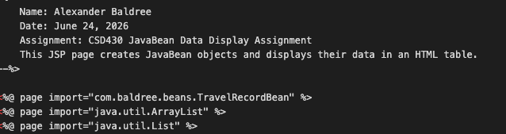

JSP Table:
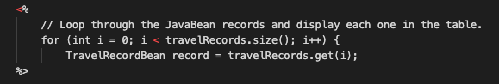

Style.css:
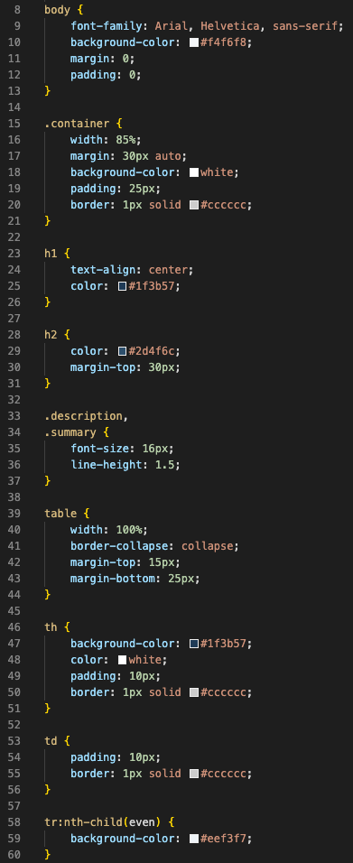

Terminal Compile:

Browser @ https://localhost:8080/Baldree4JSP/travelRecords.jsp:
